Wang Xinghui Partner  T +86 755 8293 1600  F +86 755 8293 1800  M +86 1360 2513 651  E wangxinghui@henrylaw.cn | 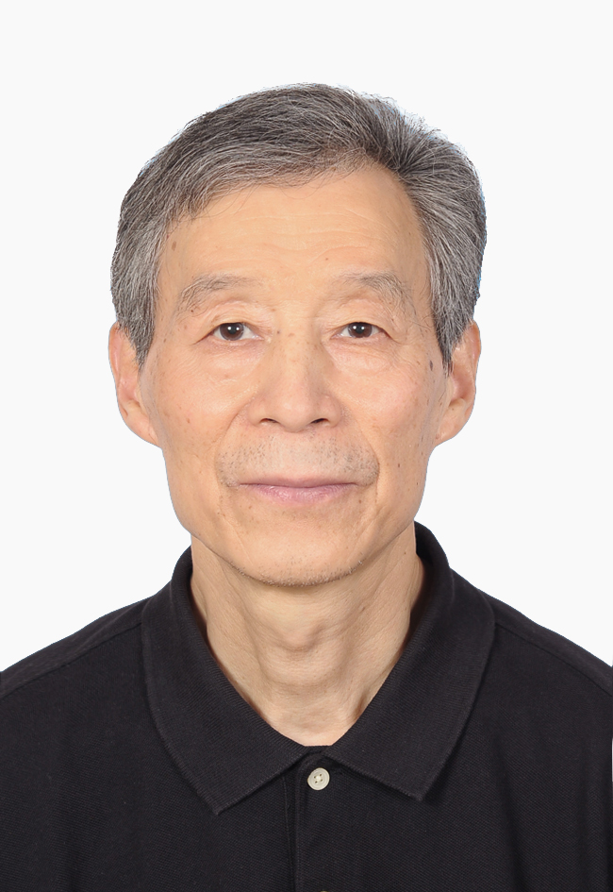
Wang Xinghui was born in 1951, Jiangxi Province.
In 1986, he obtained his lawyer's license in Shanxi Province and started his career with Shanxi Economic Law Firm. He began practicing law in Shenzhen in 1991. As a lawyer, he has handled a number of difficult and complicated cases with great impact, such as the administrative litigation cases involving Shenzhen Xiancheng Building and Shenzhen QVOD. He also handled the Shenzhen Baishi financial futures case. He has plentiful experience of working as a lawyer.
He was an executive director of Sixth and Seventh Session of Guangdong Lawyers’ Association, and a director of Third and Fourth Session of Shenzhen Lawyers’ Association also serving as a vice chair of the Committee on Protection of Lawyers' Rights. From 2001 to 2008, he was invited by Shenzhen Lawyers’ Association to give lectures on "arbitration and legal practice" to young lawyers for their pre-admission training. From 1995 to 2018, he was appointed as an arbitrator of Shenzhen Arbitration Commission, and was given the honor of “excellent arbitrator” by Shenzhen Arbitration Commission in 2000. Since 2008 he is appointed as a Mediation Expert by the Mediation Center of Shenzhen Court of International Arbitration.
The core areas of practice of Mr. Wang include intellectual property, real estate, company law, etc.
His working language: Chinese
Download full CV (PDF)

